ASSIGNMENT # 09

**Cooling Tower**

**In Case Of**

**Pre-Heater**

**EXPERIMENT # 8:**

**Effect of Pre-Heater on bench top**

**Cooling Tower Trainer**

**Introduction:**

* An air **Pre-Heater** (APH) is any device designed to **heat** air before another process (for example, combustion in a boiler) with the primary objective of increasing the thermal efficiency of the process. They may be used alone or to replace a recuperative **heat** system or to replace a steam coil.

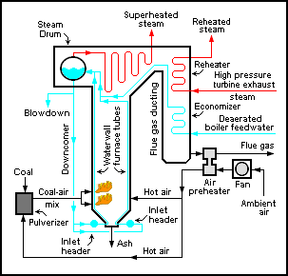**Diagram: (Figure # 9-1)**

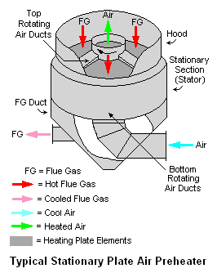

**Principle:**

**Figure # 9-2:**

* The purpose of the air **Pre-Heater** is to recover the **heat** from the **boiler** flue gas which increases the thermal efficiency of the **boiler** by reducing the useful **heat** lost in the flue gas. ... It also allows control over the temperature of gases leaving the stack (to meet emissions regulations as shown in figure # 9-2.

**Main Parts:**

* The integral **Pre-Heater** with cross flow usually includes a thermal plate that separates the feed water from there circulating flow from the down comer flow entering the tube bundle. There is a small clearance gap between the tubes and the thermal plate and leakage is possible through this gap.
  + - * The **major cooling tower as a Pre-Heater components** include
* Cold Water Basin
* **Cooling Tower** Structure
* Fills
* Drift eliminators
* **Cooling Tower** Fans,
* Water Distribution Piping's
* Fan Deck & Fan cylinder
* **Cooling Tower** Louvers,
* Gear box
* Drive shafts & Mechanical Equipment Support
* Valves
* Nozzles
* Electrical & Instrumentation systems ...
* Flow Meter
* **Heaters** (1KW and 0.5KW)
* Air Distribution Chamber
* Anemometer

**Working Of Cooling Tower as a Pre-Heater:**

* The purpose of the air **pre heater** is to recover the **heat** from the boiler flue gas which increases the thermal efficiency of the boiler by reducing the useful **heat** lost in the flue gas. ... It also allows control over the temperature of gases leaving the stack (to meet emissions regulations.
* We check actually the working of cooling tower for summer in winter. As air in summer season is hot. Therefore, we use heaters so that air will hot as it is in summer.
* Actually pre-heater is not a part of Cooling Tower.

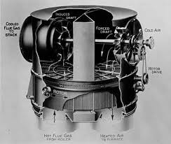**Air Pre heaters in Boiler ( APH) Figure # 9-3:**

* **Air Pre-heaters (APH)** is the **Shell and tube type Heat Exchangers** used for preheating the air which is fed to the [boiler](http://www.thermodyneboilers.com/what-is-boiler/) or furnaces/kilns for combustion of fuels. Air Pre heater’s primary objective is to extract the waste heat from the flue gases leaving the boiler.
* **Thermodyne Engineering Systems manufacture Air Pre-heaters** and are given as a standard side accessory along with the main equipment – Boiler as shown in figure # 9-3.

**Type of Air Pre heaters (APH)**

We manufacture different type of **air pre heaters**:-

* **Shell and tube type single pass air pre-heaters**
* **Shell and tube type dual-pass air pre-heaters**
* **Finned tube air pre-heaters**

### ****Applications of Air Pre heater:****

There are various kind of applications from household devices to industrial purpose where we find air pre heaters

* In refrigeration economizer system
* Ovens used in home appliances and industrial uses
* The dryer applications are heavy energy consumers in the food and non-food industry. Air pre heater transfers hot exhaust stream to the cold air inlet stream.
* In Indirect fired air heater applications.

### ****Advantages of Air Pre heater:****

For heating the air it uses heat energy of flue gases hence there are many more advantages of Air pre heaters over the normal pre heaters such as

* Increases thermal efficiency of the system
* Payback period is very short and increase combustion rate
* Improve and strengthen the combustion
* Reduces the loss of furnace and the exhaust gas temperature, improve the boiler thermal efficiency.
* Air pre heater is suitable for all standard fuels
* They are easy for retrofit into existing systems
* These air pre heaters are suitable for all waste heat boiler / flue gas boiler / boiler types.
* They strengthen the heat transfer.

**Observations and Calculations:**

|  |  |  |  |  |  |  |  |  |  |  |  |  |
| --- | --- | --- | --- | --- | --- | --- | --- | --- | --- | --- | --- | --- |
| Flow Rate | Velocity | T1 | T2 | T3 | T4 | T5 | T6 | T7 | Range | Approach | Effectiveness | Heater |
| 4 | 6.3 | 19 | 19 | 20 | 22 | 23 | 19 | 13 | 4 | 0 | 100% | 0.5KW |

**Results:**

**Range** = T5 –T6 = 23’C - 19’C =4’C

**Approach** =T6 –T2 = 19’C – 19’C = 0’C

**Effectiveness** = Range/Range+ Approach*100

**Effectiveness** = 4’C/ 4’C + 0’C *100

**Effectiveness** = 4’C/ 4’C*100

**Effectiveness** = 1 *100 = 100%

***“Thank You Teacher for Helping Me Bloom”***